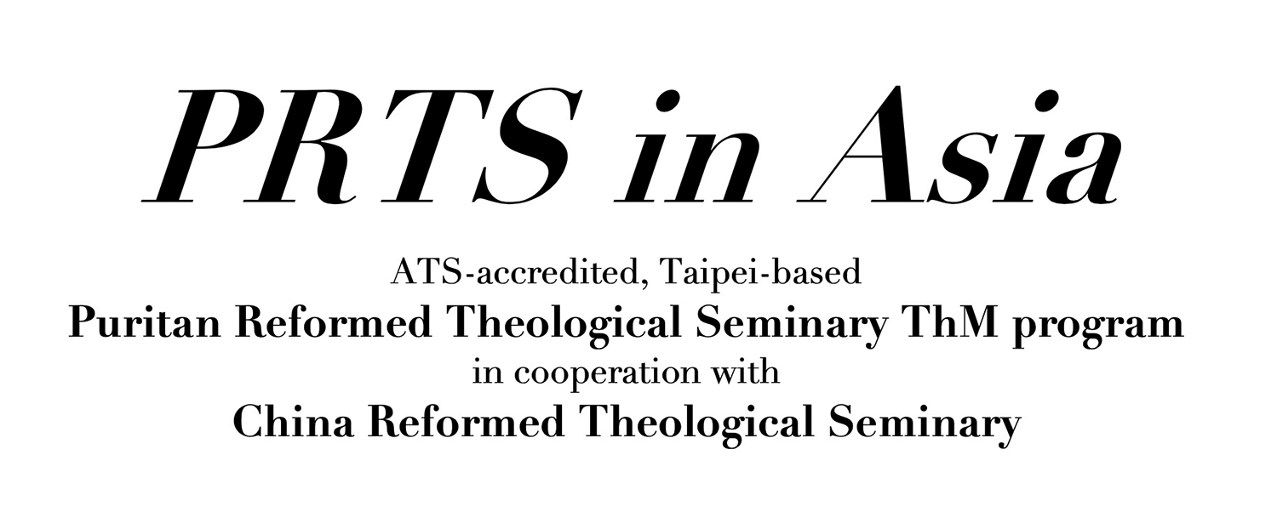

Scholarship Application Form

PRTS in Asia is able to offer a limited number of scholarships thanks to the generous contribution from our donors. In line with donor expectations, these scholarships aim to encourage students who are called to teach at a Chinese Reformed seminary. We wish to make studying at PRTS in Asia financially viable for all such qualified students with this scholarship offer.

To apply, please complete this form and email it to irene.lin@crtslive.net. Scholarship applications will be considered in January, May, August, and November.

Application Date:

Applicant Information:

Name:
Gender:
Date of Birth:
Marital Status:
Number of Children:
Residence:
Email:
Tel:

- Do you now teach at a Chinese Reformed seminary, or are you intending to do so in the future? (Please explain)

- How many ThM courses do you intend to take this year and next year?

- Please explain your financial need; include your current sources of support.

- Other relevant information.

For more information, please contact:
凌雅琳Irene, PRTS in Asia ThM Admission Coordinator,irene.lin@crtslive.net
麥安迪 Rev. Dr. Andrew McCafferty, PRTS in Asia ThM Coordinator, andymc@crtslive.net
PRTS in Asia on fb: https://www.facebook.com/prtsinasia/



